**INSTRUCTIONS:**

Use “TEMPLATE PROTOCOL (HRP-583)” to prepare a document with the information from the following sections.

Depending on the nature of what you are doing, some sections may not be applicable to your research. If so mark as “NA”. For example, research involving a retrospective chart review may have many sections with NA. For subsections you can delete it if it’s not applicable.

When you write a protocol, keep an electronic copy. You will need to modify this copy when making changes.

As you are writing the protocol, remove all instructions so that they are not contained in the final version of your protocol.

Note: If your project is a Training, Development or Umbrella Grant Application (waiting for funding with no human participant research yet) you should complete the protocol template but you are not required to submit any of the other participant facing documents.

**PROTOCOL TITLE:**

NSF INSPIRE: Gravity Spy: Teaming Citizen Science with Machine Learning to Deepen LIGO’s View of the Cosmos

**PRINCIPAL INVESTIGATOR:**

Vicky Kalogera

Center for Interdisciplinary Exploration and Research in Astrophysics/

Department of Physics & Astronomy

(847) 491-5669

[vicky@northwestern.edu](mailto:vicky@northwestern.edu)

**VERSION DATE:**

June 17th, 2016

**1.0 Purpose of the Study:**

The “Gravity Spy” project will utilize the citizen-science web infrastructure known as Zooniverse (<http://zooniverse.org/>), drawing on members of the public to help identify “noise” in data from the revolutionary new Advanced Laser Interferometer Gravitational-wave Observatory (aLIGO). The noise sources identified by citizen scientists in this crowd-sourcing project will then be entered into a machine-learning algorithm that will use those determinations to learn to filter such noise from the data, allowing human workers to advance to identifying other sources of noise. The goal of this study is to combine the distinctive strengths of large-scale computers (the ability to sift through large volumes of data) with those of humans (the ability to identify patterns and spot discrepancies). This work will then allow a high-quality characterization of the aLIGO detector.

**2.0 Background / Literature Review / Rationale for the study:**

Advanced LIGO (Advanced Laser Interferometer Gravitational-wave Observatory, or ‘aLIGO’) is the most complicated experiment ever undertaken in gravitational physics. The aLIGO detectors have already opened up the window of gravitational-wave observations on the Universe. However, the high detector sensitivity needed for astrophysical discoveries makes aLIGO very susceptible to non-cosmic artifacts and noise that must be identified and separated from cosmic signals. Teaching computers to identify and morphologically classify these artifacts in detector data is exceedingly difficult. Human eyesight is a proven tool for classification, but the aLIGO data streams from approximately 30,000 sensors and monitors, easily overwhelming a single human. We therefore propose an innovative, interdisciplinary collaboration between LIGO and Zooniverse. The Zooniverse project has fielded a workable crowdsourcing model (currently involving over a million people on 30 projects) through which “citizen scientists” provide largescale analyses of scientific data. We will couple human classification with a machine learning model that learns from the citizen scientists and also guides how information is provided to participants. A novel feature of this system will be its reliance on volunteers to discover new glitch classes, not just use existing ones. The project includes research on the human-centered computing aspects of this socio-computational system. This proposed Gravity-Spy collaboration is a natural fit with the Zooniverse Model -- engaging citizens directly in an effort to improve the chances of detecting astrophysical sources of gravitational waves.

The proposed work will help aLIGO to quickly identify noise and artifacts in the science data stream, separating out legitimate astrophysical events, and allowing those events to be distributed to other observatories for more detailed source identification and study. In the course of this project, we will also build and evaluate an interface between machine learning and human learning that will itself be an advance on current methods. The interface between human learning and machine learning can be depicted as a loop: (1) by sifting through enormous amounts of aLIGO data, the citizen scientists will produce a robust “gold standard” glitch dataset that can be used to seed and train machine learning algorithms that will aid in the identification task; and (2) the machine learning protocols that select and classify glitch events will be developed to maximize the potential of our citizen scientists by organizing and passing the data to them in more effective ways. This includes, but is not limited to, the evaluation of a citizen scientist’s skill level (Beginner, Apprentice, and Master). There are three beginner levels, one apprentice level, and one master level. The skill level of a citizen scientist will impact the difficulty of the identification task given to them. While we have robust models for the first part of this loop, we know little about how using machine-coded data will improve human learning and performance. The project will experiment with the task design and workflow organization (leveraging previous Zooniverse experience) to build a system that takes advantage of the distinctive strengths of the machines (ability to process large amounts of data systematically) and the humans (ability to identify patterns and spot discrepancies), and then using the model we develop to enable high-quality aLIGO detector characterization and gravitational-wave searches.

**3.0 Inclusion and exclusion criteria:**

This project will be open to all current members of the “Zooniverse” website as well as the general public. (There are currently approximately 1,300,000 participants on the Zooniverse website.) We do not have a limit on the number of participants for the Gravity-Spy project, and do not have limiting participation criteria; also, we do not require subjects to enter their name (if they do enter a name, that name is not used in our data analysis).

Our only exclusion criteria is that each person who uses the Zooniverse website must agree to a notice of Informed Consent, which will require that participants need to be at least 18 years old; therefore, we expect only adults will be included. (Pregnant women may be included, but they are not specifically targeted as our study does not concern those particular groups.)

**4.0 Procedures Involved:**

This study utilizes the Zooniverse website (<http://zooniverse.org>), which each participant will access from a computer that they have access to, in their own setting. The analysis of the participant’s work will take place at two of our collaborating institutions: the Adler Planetarium and Syracuse University. In addition, the evaluation of a user’s skill level, which will utilize the classifications made by the participant, will be processed at Northwestern University.  
  
The *study design* of our proposed Gravity-Spy project comprises five tightly coupled components bridging four scientific areas. The five components (LIGO entity, Machine processing, Human processing, Data stores, and Research measures) constitute a two-way feedback loop between the learning of machines and humans. The humans include the LIGO science team members as well as citizen scientists of increasing levels of skills and knowledge (Beginner, Apprentice, Master, and Expert). The formulation and methodology allow us to address research questions regarding machine learning, human-centered computing as well as to continually improve glitch classification, effectively addressing the detector-characterization challenge for aLIGO.



The above diagram provides a top level view of how these disciplines interplay with each other in this project. In the next paragraph, we describe how the interplay works in practice.

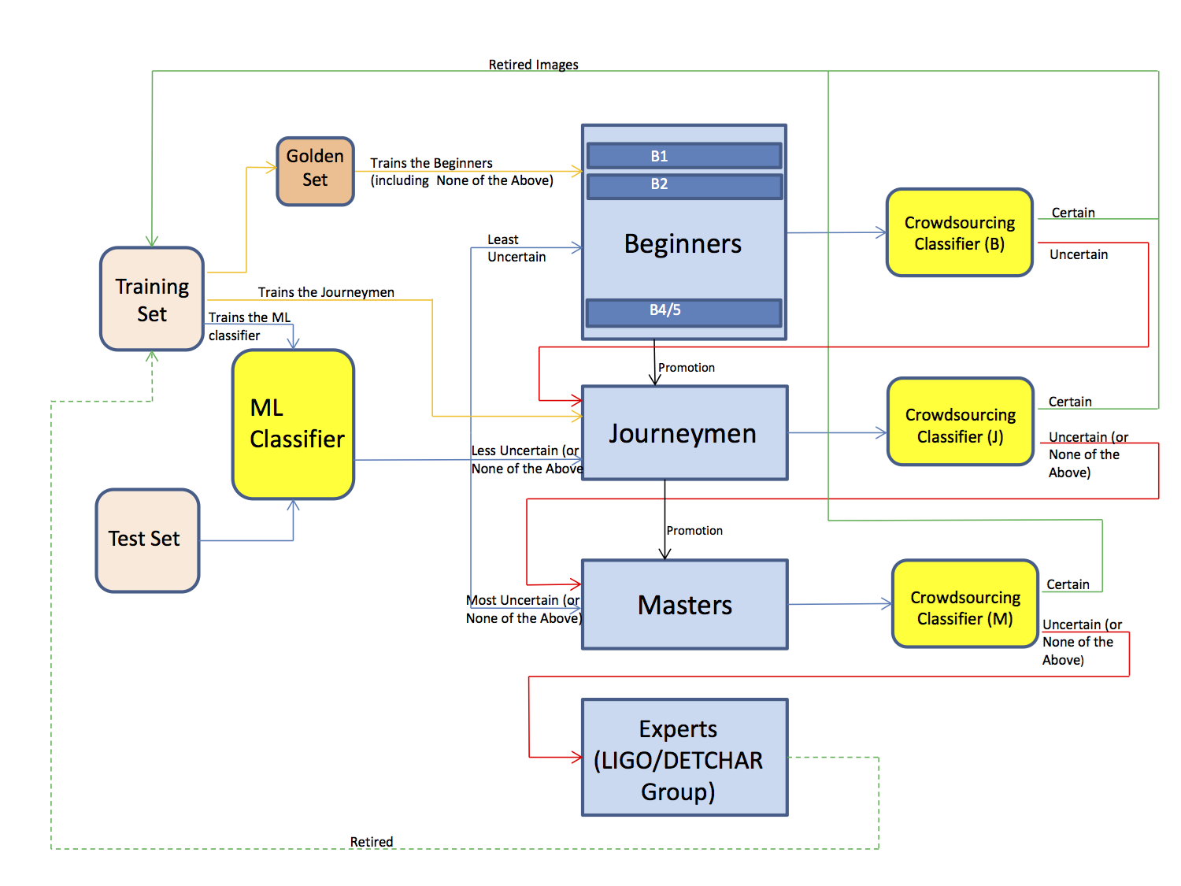

Our planned system architecture is illustrated in the above figure, showing the interconnectivity and interaction between the following five key components: **First**, through the LIGO members of our team, the external LIGO data feed, called the test set, (orange) provides data glitches to the Gravity-Spy system. **Second**, the machine learning (ML) unit (yellow) processes data glitches into known classes with some degree of confidence. Glitches for which the confidence level is high can be used after vetting by beginner level Zooniverse volunteers. Images for which the classification confidence is low will be to more skilled users. If a consensus cannot be reach by the volunteers, the image will be studied and processed by the LIGO detector characterization experts. **Third**, Gravity-Spy volunteers (blue) make up the human-classification and human-clustering units. Based on a known taxonomy of glitches, Beginner and Apprentice-level participants classify the unknown glitches (coming from the ML unit) as being examples of known or novel classes in the human-classification unit. Masters can examine the potentially novel glitches to identify and describe additional classes of glitches in the human-clustering unit. **Fourth**, there are two data components (also orange): the training and the gold-standard datasets, which store descriptions and examples of glitch clusters, prepopulated from the current LIGO team and added to by the work of the human-clustering unit (shown by the green arrows). The gold-standard set also receives information from the human-vetting and human-classification units and provides information back to the ML unit to improve ML algorithms and resulting classification, as well as to the LIGO project for their analysis and hopefully, elimination.   
  
The Gravity-Spy program of study is funded for 37 months (starting one month early with pre-spending authorization), starting Sept 1st, 2015, and continuing through Sept 30th, 2018. Interaction with human subjects has begun in the second year of the program (starting October 12th, 2016). Any of the individual participants, from the public, will be able to take part this program. Each participant works on this program as a volunteer, in their own free time.

For each participant, data is collected on the performance of the participants on the sorting task (the identification of noise in aLIGO data); for each choice from each participant of whether a particular dataset seems consistent with a known (or unknown) noise source (see below for an example choice), we store that choice. We will use the data collectively, to build a computer-database of known glitches and unknown, possible glitches.

From the point of view of most participants, their interaction with the Zooniverse system will look like the image below. In these individual multiple-choice questions, participants will be presented with images of glitches from aLIGO and asked if they fit an existing category of known glitches or if the glitches represent a novel category. More advanced users will be able to work on grouping novel glitches together into new categories.

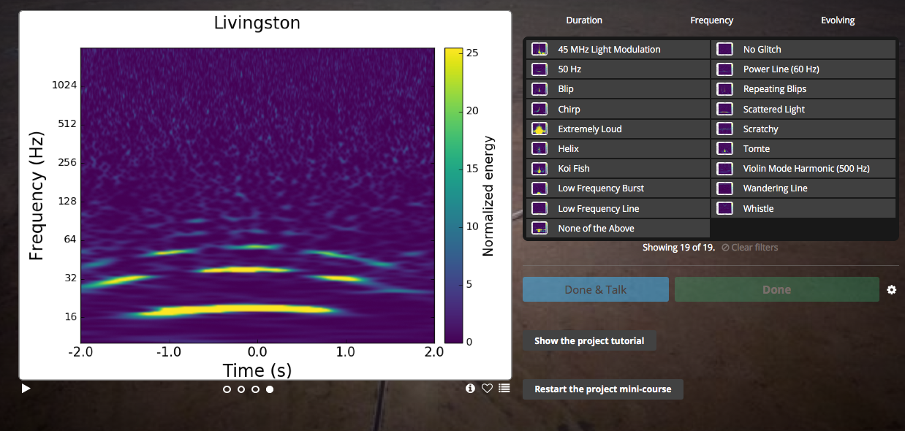

During their work on the system, participants will see different kinds of experimental interventions (e.g., different presentations of glitches, training, motivational messages, suggested team processes, potential clusters of novel glitches) to identify which are most helpful in improving performance and other outcomes.

These experiments have been designed in year 1 and will be implemented in year 2. As participants perform the citizen science task, various data about their performance can be tracked, specifically time spent on the task and agreement of their classification with others (and potentially with known results, for a subset of data). These system-level data will be analyzed in an aggregate fashion (e.g., average performance under different conditions). Samples of participants will be surveyed periodically to obtain data about participant attitudes towards and beliefs about science and the science task. The surveys have been developed in year 1 and will be deployed in years 2 and 3.

The Zooniverse web interface also collects data on when users log in, pages that they look at, and posts to the “TALK” (discussion forum) pages, as well as the classifications that each participant makes. For the Gravity-Spy program, data will only be analyzed in year 2 and beyond, when the Gravity-Spy program is available (with informed consent before volunteers can participate).  
  
On this project, research will be conducted at Northwestern University, at the Adler Planetarium, at Syracuse University, and at California State University, Fullerton. All of those institutions will be separately reviewed by their individual IRBs, and we will attach the determination of each institution’s IRB review to this proposal. (NB: The Adler Planetarium will be reviewed by the IRB at Syracuse University.)

Prior to this work commencing, and after the review of all of the individual IRBs involved, we will submit those results to the NSF, to receive funding for the INSPIRE project.

**5.0 Multiple sites:**

While the work that each participant completes, as part of this project, is always local to that participant (on her/his computer), there will be four different sites that will contribute to this project, each with different strengths.

We note that the National Science Foundation grant which funds this project is housed at Northwestern University, which leads the program.  
  
Here are the roles of each site:

***Northwestern University:***  In year one, Northwestern researchers have identified and tested machine learning (ML) classification algorithms, using a small set of pre-classified glitches for ML training.

In addition, they have customized and implemented several ML algorithms, embedded within the Gravity-Spy infrastructure, so the results can be fed to the human-classification task. In addition, with help from Fullerton researchers, Northwestern researches helped prepare a large database of available LIGO glitches, along with metadata relevant to classification, and helped prepare a small set of glitches pre-classified by LIGO experts. They will produce a (still imperfect) glitch set for use in the first-stage Gravity Spy by citizen scientists. In year 2, with the public launch of the website, they continue to engage with citizen scientists on TALK (a discussion forum on Zooniverse) and provide blog and social media updates. In the second year, researchers at Northwestern are identifying and testing clustering algorithms that will be used in a two-way feedback loop with the human-clustering task, using the gold-standard dataset produced by humans to improve ML algorithms and classification results. Finally, in the third year, they will collect, assess, and analyze classification results from the advanced human classification and clustering tasks, compare classification results and newly-identified glitch classes dependent on different training the volunteers receive, and continue to engage with citizen scientists on TALK and provide blog & social media project updates.

***Syracuse University:*** In year one, Syracuse researchers planned experiments and surveys on motivation and learning to be implemented in Year 2, consulted on the implementation of the first phase of Gravity Spy and will participate in the design of the human clustering process. In the second year, they will plan experiments and surveys to be carried out in Year 3 with participants developing novel clusters, will consult on the Adler’s implementation of the human-clustering phase, and will carry out experiments with participants in Gravity Spy. Finally, in year three, they will carry out experiments and surveys with participants in all phases of the Gravity Spy including experimentation with: ML support of glitch clustering, organization of clustering activity (individual and collective), and task design.

***Adler Planetarium:*** In year one, the Adler Planetarium group was responsible for prototyping and testing 2-3 versions of the human-classification task, designing, developing, and launching the first-stage Gravity Spy, and developing training interventions for the human-classification task including the experiment module. In year two, Adler researchers will Prototype and test 2-3 versions of the human-clustering task, design, develop, and launch the second-stage Gravity Spy with human classification and clustering tasks, and develop training interventions for the human-clustering task including the experiment module They will also deploy experiments as needed. Finally, in year three, they will continue to run and update Gravity Spy, continue to track volunteers’ interest and performance (dependent on different training paths), and deploy more experiments as needed.

***Cal State Fullerton:*** In the first year of this program, Fullerton researchers helped prepare a large database of available LIGO glitches, along with metadata relevant to classification, and helped prepare a small set of glitches pre-classified by LIGO experts. In addition, they engaged with citizen scientists on TALK system (a discussion forum) and provided blog and social media project updates; these entries will be part of the study in year two. Also in year two, they will use the gold-standard dataset to analyze the most common glitch classes and start investigating their causes, continue to engage with citizen scientists on TALK, and provide blog & social media project updates. In year three, this group will analyze the full database of classified glitch categories to develop relevant vetoes and to help track their origin within the LIGO detectors, and will continue to engage with citizen scientists on TALK and provide blog and social media project updates.

Each of these sites will submit a proposal to their local IRB office to gain the required approvals. Such approvals are required before the project is allowed to begin. (Syracuse has already obtained the approval for the first year of work.)  
  
To keep these sites in sync, the senior personnel in the project will have face-to-face meetings one per year; in addition, there will be regular (at least monthly) teleconferences to discuss ongoing issues. The team members will also utilize a team email list, Dropbox, Google Docs, Slack, and Trello for sharing ongoing questions and relevant documents. The consent document will be developed in collaboration between our senior personnel (on this project) and the Zooniverse developers, and circulated to all members of the research team.

All members of the research teams who work with the participant data are made aware of the privacy policy and practices by reviewing the Privacy Policy before joining the Zooniverse team. The Zooniverse project uses industry-best practices to secure user data, and access to the database and logs are limited to the research group and system administration group.

Citizen-science data related to this project will be stored at the Adler Planetarium; for any citizen-science data that is stored at Northwestern University (for temporary use as the Machine Learning [ML] algorithms are being developed, for instance), that data will not include personally identifiable information.

To protect the privacy of every individual who participates, the Zooniverse project already holds data in compliance with both the United Kingdom Data Protection Act 1998, and the Freedom of Information Act 2000, and as well as United State regulations regarding the protection of human subjects in research (this exact text is from the privacy policy supplied to each participant). For the start of the project, all data will be housed at the Adler Planetarium, which houses the data for the other Zooniverse projects, as well.

**6.0 Incomplete Disclosure or Deception:**

Not applicable.

**7.0 Recruitment:**

Subjects will be recruited from among current participants in the Zooniverse projects by an email announcing the new project. This email will include a short text description of the work we would be asking for help with, along with a link to the Gravity-Spy Zooniverse project. When participants sign up for the project, at that website, they will receive further information about the social science research goals and the human-subjects data collection as part of the informed consent process.

We will also send a similar email to our Northwestern CIERA public email lists, asking for volunteers to help in the process (using a very similar email and the same process, where when possible volunteers log on to the website, they will receive further information about the research goals, and human-subjects data collection).

**8.0 Consent Process:**

The informed consent of all participants will take place when each participant creates an account on the Zooniverse website to work in the Gravity-Spy study. Even if participants have already agreed to another Zooniverse-based project, they will be asked for their informed consent for this particular project (the Gravity-Spy project).

At present, when we are involved only in Year 1 of the study, we will not be working with participants in the Gravity-Spy project; the informed consent notice will be developed as part of the first year work.

**9.0 Process to Document Consent:**

Since, in Year 1 of the study, we will not be working with participants, we will develop these procedures in Year 1, and document the entire procedure for Year 2, starting October 1st 2016, of this multi-step project.

**10.0 Risks to Participants:**

This research will not expose the human participants to risks, discomforts, hazards, or inconveniences beyond those encountered in daily life. Participants are able to withdraw at any time without penalty, at their own request: they can simply discontinue their use of the Zooniverse system. The contributions of any participant who has withdrawn from the Gravity-Spy program are generally used after their departure; however, in the Privacy Policy that each user receives, they are asked to contact the Zooniverse team if they have particular concerns about their data.

**11.0 Potential Benefits to Participants:**

Citizen Scientists taking part in this program will gain experience in the discovery process of modern data-intensive science, and will be part of the discovery process of the aLIGO detector. Participants who supply their real name will be publically thanked in presentations and publications.

**12.0 Financial Compensation:**

There is no financial compensation for participants.

**13.0 Provisions to Protect the Privacy Interests of Participants:**

As part of joining the Gravity-Spy program, users will be presented with a Privacy Policy that describes how the steps that will be taken to protect their privacy. As mentioned above, the Zooniverse project operates in accordance with the United Kingdom Data Protection Act 1998 and the Freedom of Information Act 2000, as well as with United States regulations regarding protection of human subjects in research. That data is stored and handled by Amazon Web Services, which is a participant in the “Safe Harbor” program developed by the USA Department of Commerce and the European Union (EU). Amazon has certified that it adheres to the Safe Harbor Privacy Principles agreed upon by the USA and the EU.

Members of the research teams are made aware of our privacy policy and practices by reviewing this statement upon joining the team. They follow industry-best practices to secure user data, and access to the database and logs are limited to members of the research group and system administration staff.

**14.0 Confidentiality and Data Management:**

The data stored about each user consists of their own username and e-mail address (each participant’s e-mail address is not visible to other users), as well as logs that record when each participant logs in to the system, and which pages they view. Each user may *(optionally)* supply their real name, to be included when participants are thanked publically in presentations & publications; names are only associated with overall projects (the Gravity Spy, in this case), and not with particular classifications or “answers” given on the website.) The Zooniverse system, of course, also stores classifications that are made by each participant, and any posts made on the “TALK” discussion forum; data from the TALK system will not be used or analyzed for Gravity Spy until the second year of the program, when the Gravity Spy program “goes live.”

Each participant’s data is stored on the website, which is built on [Amazon Web Services](http://aws.amazon.com/). Amazon is a participant in the Safe Harbor program developed by the USA Department of Commerce and the European Union (EU). Amazon has certified that it adheres to the Safe Harbor Privacy Principles agreed upon by the USA and the EU. The data is stored for as long as the project is active.

Only members of the research team and system administrators are granted access to the secure user data. All members of the research team are made aware of the privacy policy and practices when they join the team.

Detailed steps for this particular data (especially the possible sharing of the data between the various sites of the program) will be developed in the course of work for Year 1.

**15.0 Data Monitoring Plan to Ensure the Safety of Participants:**

The data retained as part of this program will not affect the safety of the participants.

**16.0 Data and if applicable, Specimen Banking:**

Data will be retained for future use; the data will be stored as part of the Zooniverse system, which is built on Amazon Web Services, described above. Data for this project will be stored beyond the three-year lifetime of this grant program. The only group that will have access to this data beyond the study period will be the researchers and system administrators of the Zooniverse program, working at Adler Planetarium.

As we further refine the data plan in Year 1 of this project, we will address whether data can be released; data will not be collected until Year 2 of the project.

**17.0 Qualifications to Conduct Research and Resources Available:**

The Zooniverse project (managed chiefly by Adler Planetarium and Syracuse University) have previously developed and are now running 33 different “Citizen Science” projects; while the Gravity-Spy project does have some new components, it is largely similar to these other projects, so the facilities and expertise for the public-facing components of this program already exist. They also have the experience in dealing with a very large number (over 1,300,000) participants. Meanwhile, the groups at California State, Fullerton and Northwestern University have the expertise to manage the interface with the LIGO project and LIGO data; this collaboration is uniquely suited to both handle the public interface, and the detailed scientific studies that will be aided by the development of this public interface and the inclusion of citizen scientists in this project.

As mentioned earlier, all researchers involved in this project will be exposed to the Privacy Policy as they join; in addition, the senior researchers in this project will meet regularly (at least once per month) to discuss the project in general, and in particular, any changes in the protocols, which will then be communicated to other researchers at each institution.

R: 6/17/2016